Clone the git@github.com:shajivmasters/Assignment.git and do a terrform init

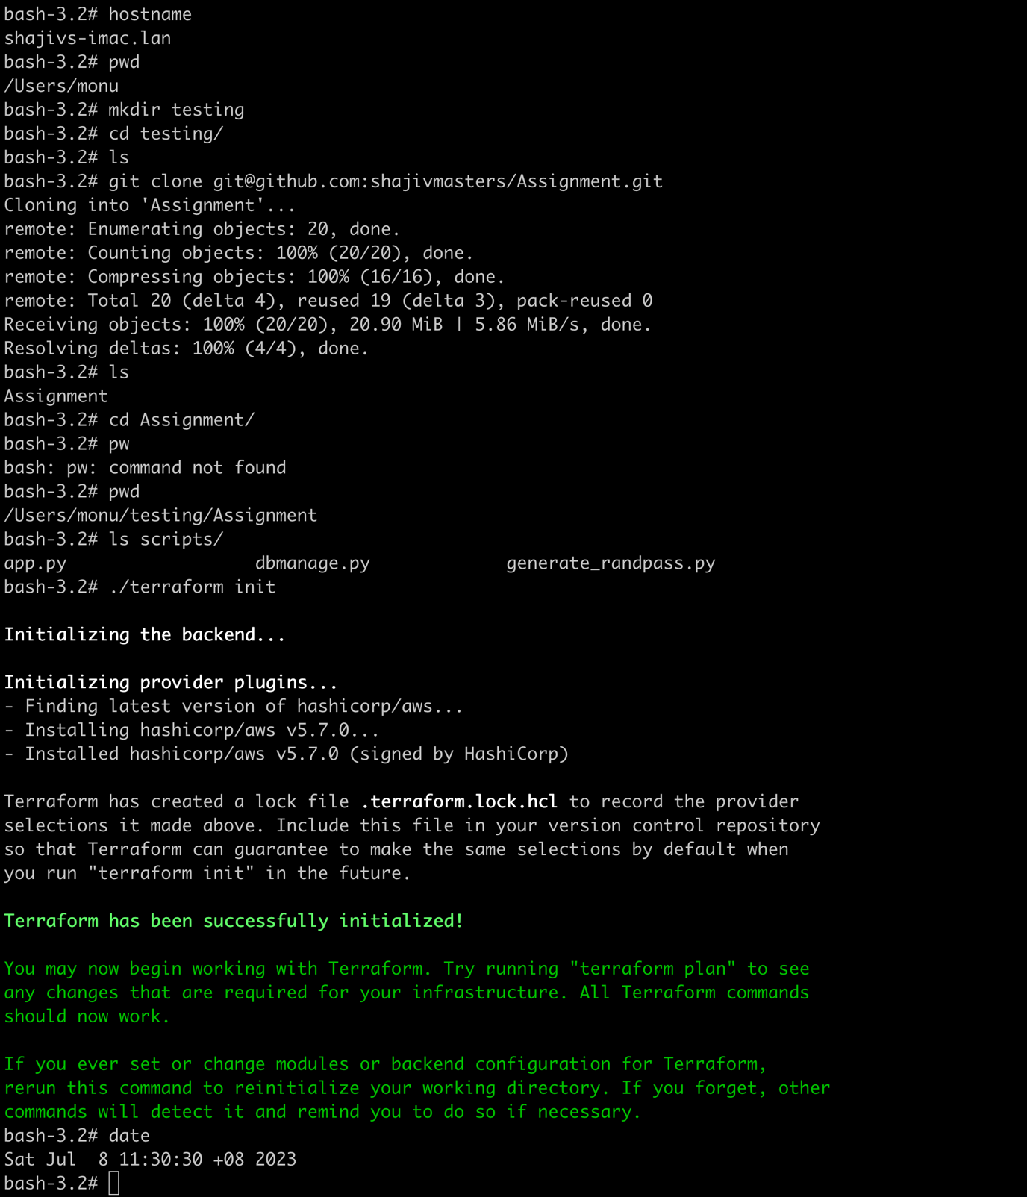

Doing a terraform plan

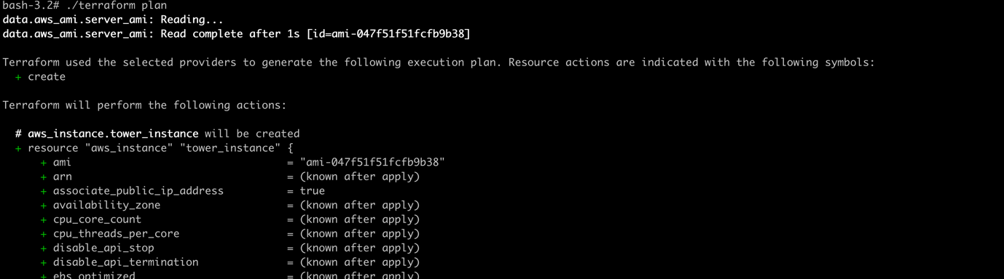

…..

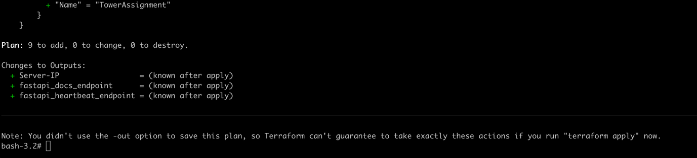

Doing a terraform apply. This will output the Public IP and FastAPI endpoint after the deployment

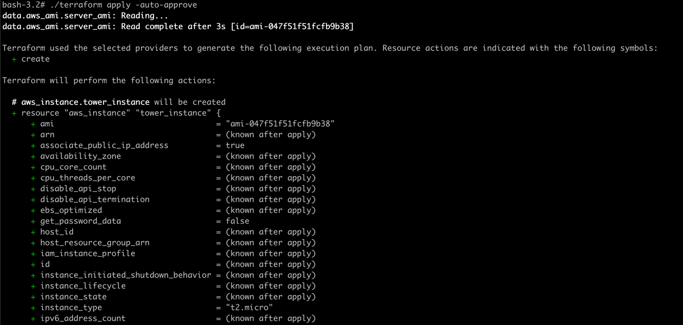

…

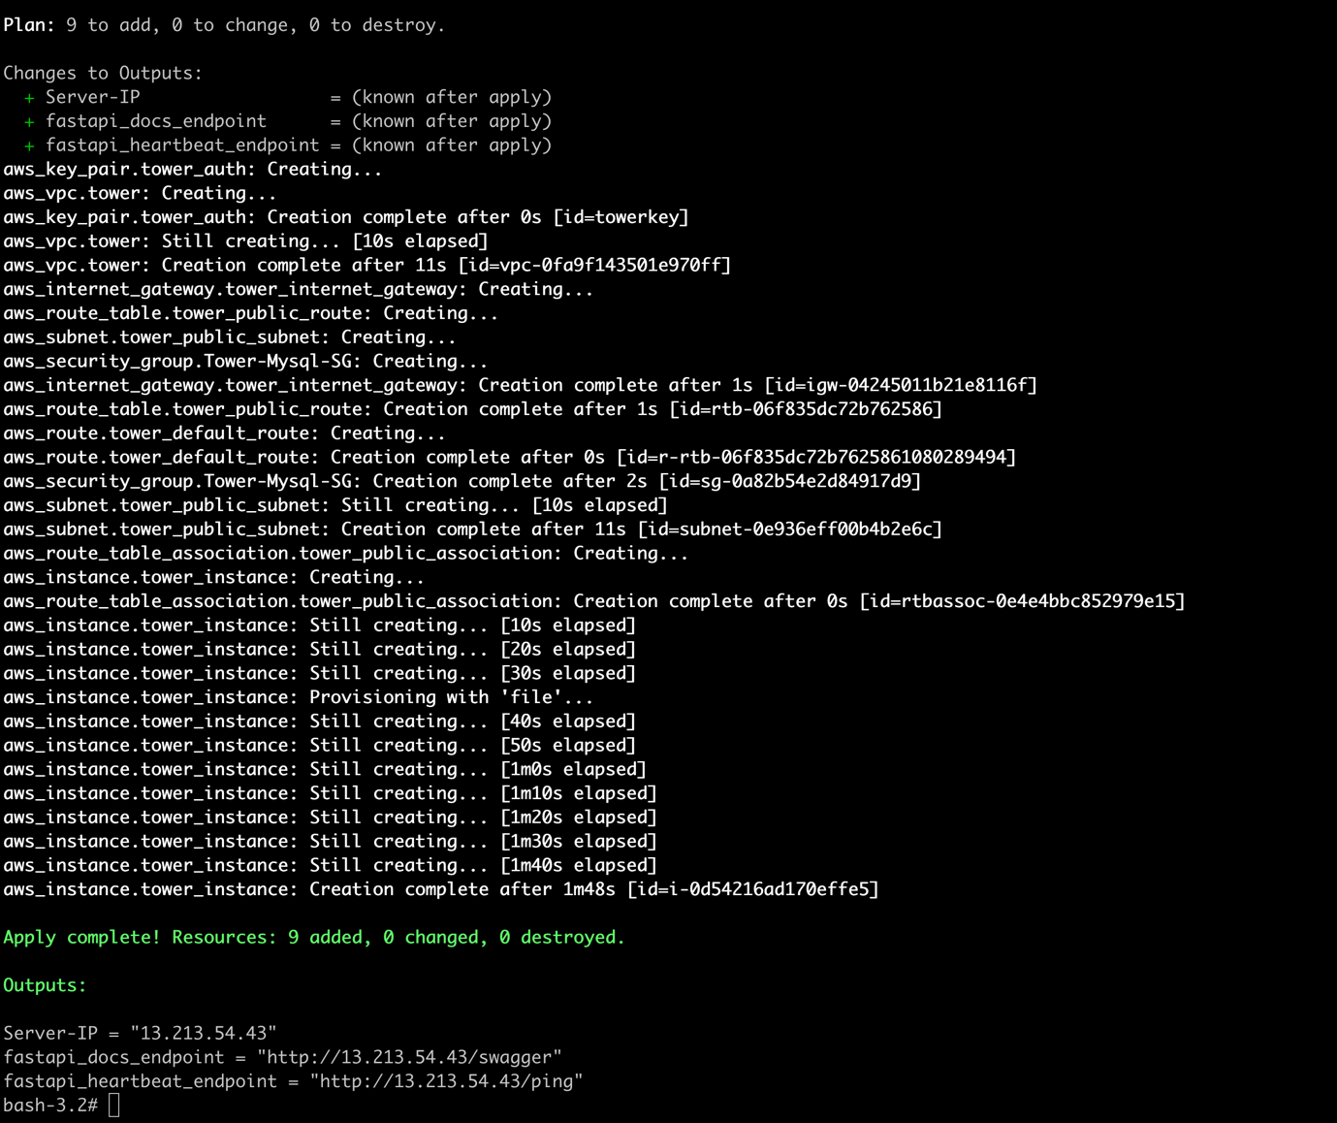

You can see that the above give the information of the EC2 instance and FasrAPI end point

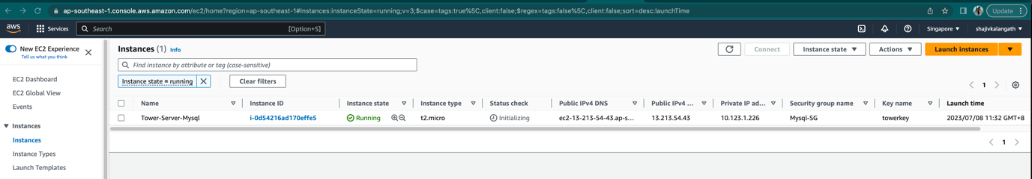

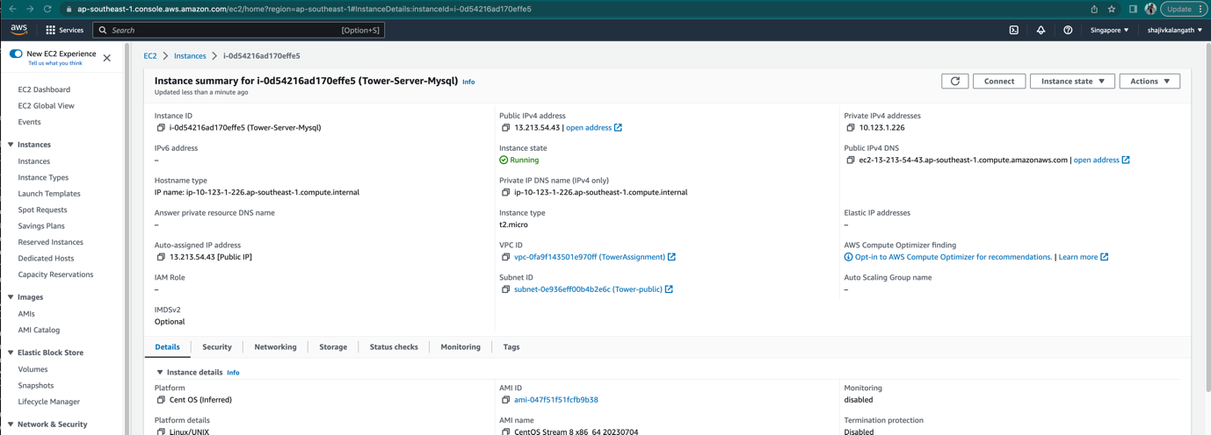

Wait for 3 to 5 minutes to login. We also test before configuring the DB and it gives the error

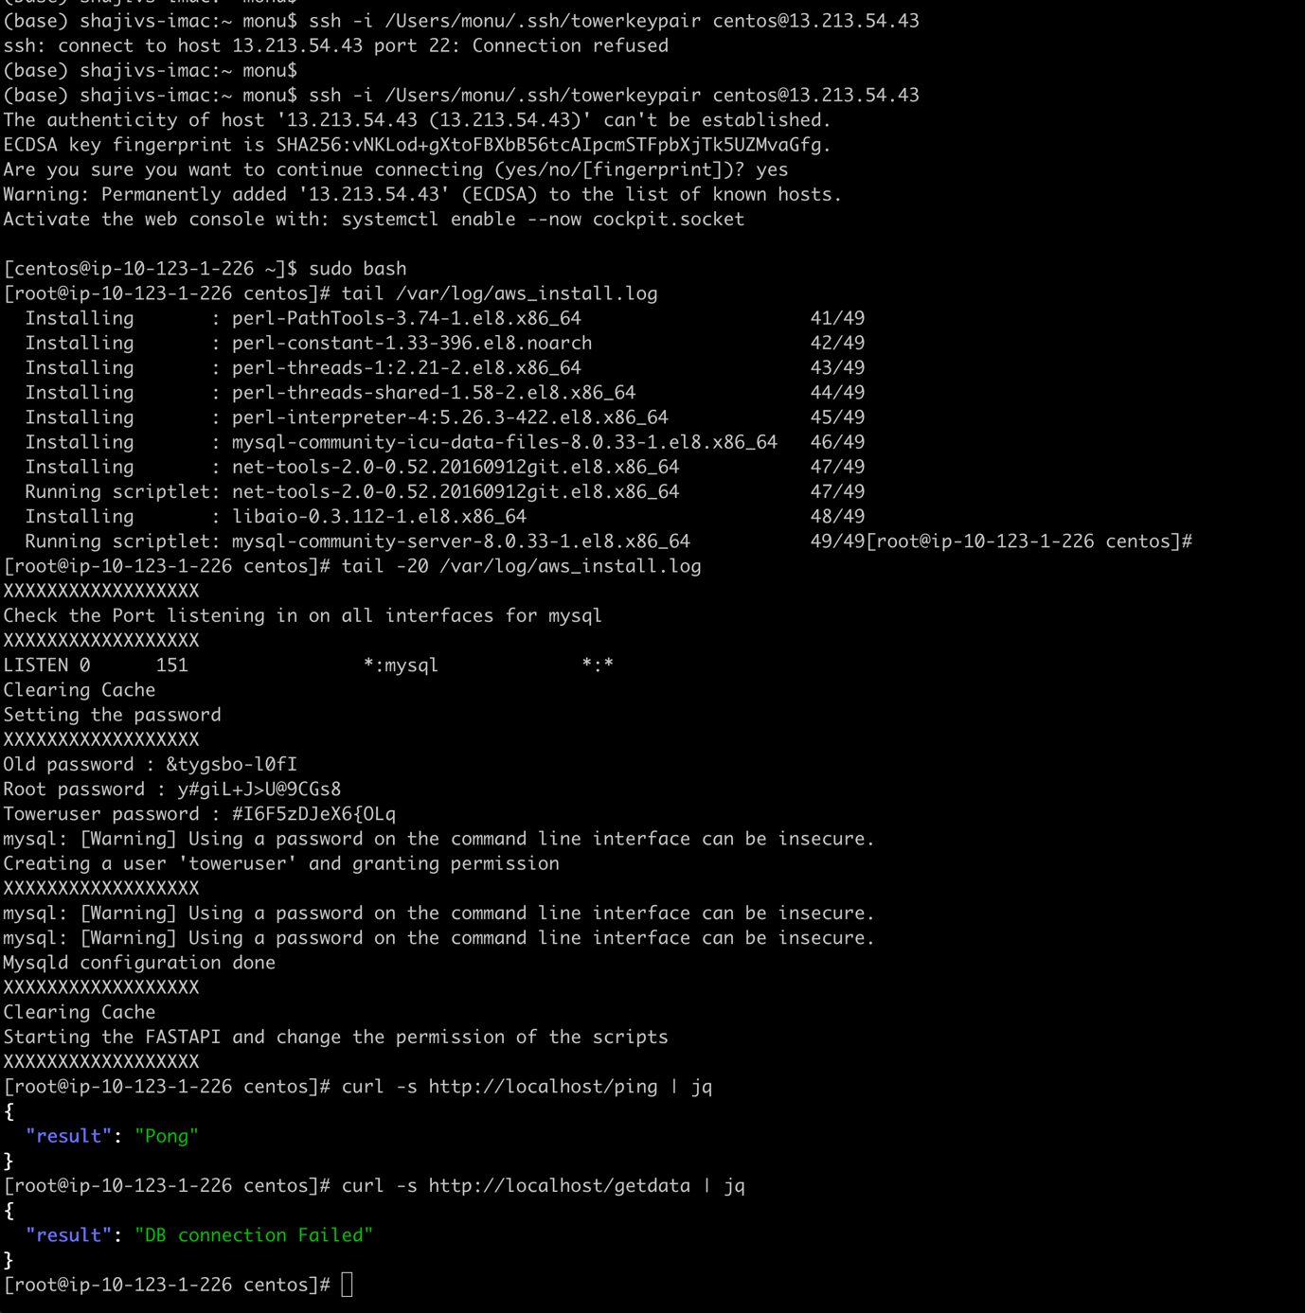

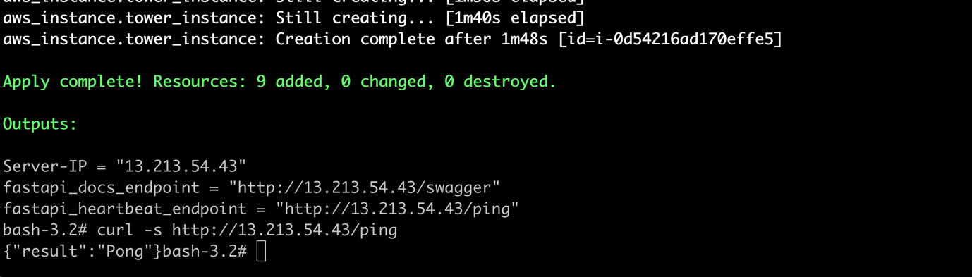

You can see that it is accessible via public IP address

You can see the “ping” “pong” reply to check the heartbeat/status of the API endpoint

As you can see we are making the script to configure the DB. You can see the interface are configured and updated in the mysql configuration files

You can see below using the “/home/centos/scripts/dbmanage.py create” bootstrap the DB with the required information. The script is copied part of the Infrastructure deployment.

You can access publicly as well using the curl command



You can use through swagger to test as well as shown below

If you run this again and if the DB is already configured it will not mess up it just comes out also you can see the /var/log/fastapi.log for some debugging



The log for fastapi is available at “/home/centos/scripts/fastap.log”

Configuring using Swagger UI

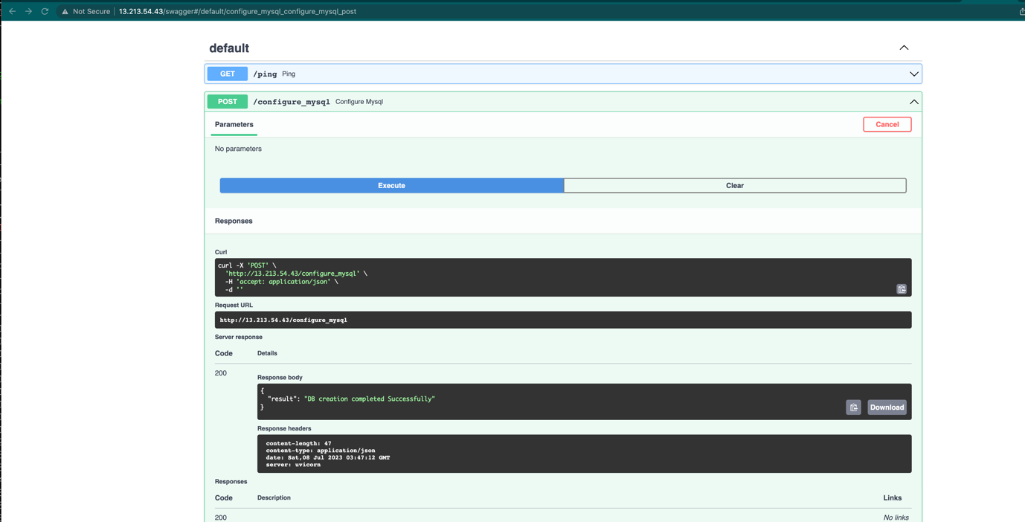

Below the IP address is removed and we configured through the swagger UI.

Using the /home/centos/dbmanage.py to query/update/insert and delete the data .

* We inserted the data for the user “shajiv” the Filed1 is optional and it is the current date and time
* We updated the Field3 and it updated the Field3 and Field1 ( With current time)
* We updated the entry for Field3 and Field1

* We deleted the data for “Shajiv”

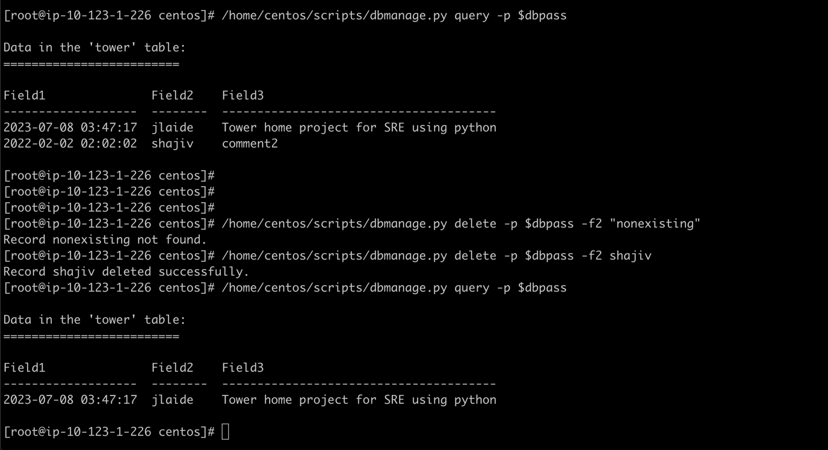

Using the Swagger UI to manage the DB .

* We added the entry for “Shajiv” using the swagger UI

We have tried to update with an Invalid entry for Data and it gave the error “Invalid datetime format for field1. Format should be: YYYY-MM-DD HH:MM:SS”

* With valid format we were able to update the DB

* View the data in the table and remove the data using the /delete endpoint

Trying to delete a non-existing entry it says “Record not found”

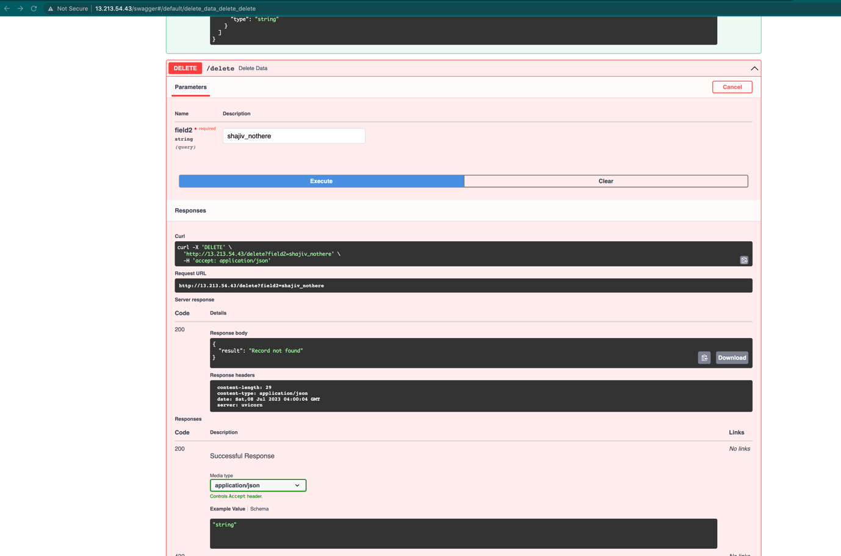

Confirm the deletion of the record

* Using the CURL command to achieve the same

